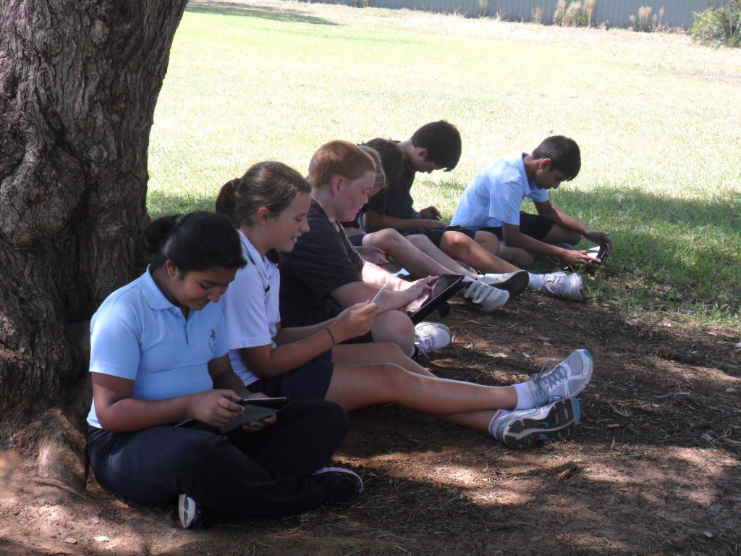Primary student use of mobile phones and personal devices

### Purpose

This policy provides direction to students, staff and families about managing mobile phones and other digital devices that students choose to bring to school. Digital devices include, but are not limited to, smartwatches, tablets or laptops that are not part of a separate Bring Your Own Device arrangement. This policy applies while students are at school, or attending an authorised school activity such as an excursion, during school hours.

### Main points

* **Students are not permitted to use mobile phone or personal devices during school hours (8:30am – 3:20pm)**
* **Parents must use school procedures (i.e. call Front Office or email teacher) to deliver a message to their child during school hours**

Mobile phone use for primary school students

The department’s position is that primary aged students cannot use their mobile phones and personal devices at school during school hours. The department and the school recognise that there are legitimate reasons for students to bring a mobile phone or personal device to school. This may include:

* to ensure their safety while travelling
* so that parents can contact them outside of school hours.

During the school day students are not permitted to access or use their mobile phones or other personal devices. Students must switch off or mute their devices before storing them at the beginning of the school day. They will not be able to access their device until the end of the school day.

Storage of personal devices

If a student has a legitimate reason to bring their mobile phone or have a personal device at school it is a requirement that they give it to the class teacher where it is stored in a safe and secure area and at the conclusion of the day it can be signed out and collected

If the student does not comply

* If a student doesn’t sign the mobile device in, the mobile device will be confiscated, and a parent and/or guardian will be called to collect the device.
* Misuse of mobile phones or personal devices may result in disciplinary action which includes but is not limited to the device being confiscated. Confiscated devices will be taken to the front office for secure storage and parent contacted. Confiscated devices will remain in secure storage until they are returned to a parent. Where there is a repeat of misuse or refusal to follow reasonable instruction to hand in a device when asked, we will refer to the school behaviour agreement policy which may include further steps such as admin time out, internal suspension or suspension.

Roles and responsibilities

**Principal**

Make sure:

* this policy is clearly communicated and accessible to all students, staff, and families
* there is a process for regular review of the policy
* secure storage is provided for student personal devices that are handed in to school staff
* processes are in place for monitoring internet and school network use by all members of the school community.

Enforce the policy and responses to instances of non-compliance.

Report and respond to incidents of inappropriate use of personal devices in line with department policy and procedures and any legislative requirements.

Consider requests for exemptions from the policy from parents on a case-by-case basis. Make sure that approved exemptions are documented and that relevant staff are informed about students’ exemptions.

Model appropriate use of mobile phones and support families to understand the importance of promoting safe, responsible and respectful use of mobile phones to their children.

**School staff**

Deliver learning opportunities and maintain a safe and productive learning environment. Take steps to minimise distractions from the non-educational use of personal devices in the learning environment at times when a device is being used by a student in line with an approved exemption or in circumstances where students’ devices are stored in the classroom.

Respond to instances of non-compliance in line with the school’s policy.

Report and respond to incidents of inappropriate use of personal devices in line with department policy and procedures and any legislative requirements.

Make sure that any student personal devices handed in for their care are stored in a secure location and are returned to the student (or their parent).

Model appropriate use of mobile phones and support families to understand the importance of promoting safe, responsible and respectful use of mobile phones to their children.

**Students**

Comply with the requirements of the school’s policy and follow all reasonable directions from the Principal and school staff.

If permitted to use a mobile phone or personal device in line with an exemption under this policy, do so in a safe, responsible and respectful way and support peers to do the same.

Communicate respectfully with others and do not use a mobile phone or other personal device to bully, harass or threaten another person.

Respect others’ rights to privacy and do not take photos, film or audio records of other people without their knowledge or permission.

**Parents**

Support the implementation of the school’s policy, including the consequences for non-compliance with the policy.

Use the school’s formal communication channels in all instances to communicate with the school (including where a student requires early collection from school). Encourage their child to always report to a school staff member in the first instance if they become unwell or experience an issue at school.

Recognise the important role they play in supporting their child to use their mobile phone (or other personal device) in a safe, responsible and respectful way.

Communication and review

* Staff
* Governing Council
* Student Leaders
* Student Families

Supporting information

* school behaviour agreement,
* school anti-bullying policy
* BYOD policy, ICT user agreements

Policy Dates

Implemented : Next Review Date: Ratified by Governing Council: